ULTRASONIC TESTING REPORT
Company/Client |  | NCOC N. V. |  | Project |  | ESKENE WEST |  | Location |  | Oil Tr2 Unit 210
Line No/Tag No: |  | A1-2102-RO-087-3”-A11-HC |  | Material |  | A333 Gr.6 |  | Día × Nominal Thickness |  | 2”x5.54mm
Procedure No: |  | QP-11-UTT-Q01 Rev 04  GOST 28702-90 |  | Calibration Block |  | Step wedge |  | Probe  S/N |  | D7908  1214571
 |  |  |  | Calibration block Range |  | 2.5-12.5 mm |  | Angle |  | 0º
Manufacturing Code |  | ASME B31.3 |  | Calibration Temp |  | +25ºC |  | Frequency |  | 7.5 MHz
 |  |  |  | Object Temp |  | +27ºC |  | Size |  | 5.1 mm
Acceptance Standard: |  | Acc. to the client specif. |  | Correction factors |  | n/a |  | Crystal |  | Dual
Surface condition |  | Coated |  | Couplant |  | UT Gel |  | Accuracy |  | ± 0,1 mm
S. No | Equipment/  Material Name |  | Manufacturer |  | Serial No |  | Calibration certificate No |  | Calibration Expiry date
 | DL-38 |  | OLYMPUS |  | 183107401 |  | BK-01-0079 |  | 05-02-2021
 | Step wedge calibration block |  | NDE-TECH |  | NDE-8365 |  | - |  | -
Job description:

- UT spot check performed on line A1-2102-RO-087-3”-A11-HC (drawing No: KE01-A1-210-PO-R-DI-2906-001).
- P&ID scheme No: KE01-A1-210-PO-R-HP-0203-001.
- Echo to echo UT technique was used.
- Inspection performed on East, West, South and North from external.
Notes:
N/A – not applicable.
FSH - Full Screen Height

Inspection drawing
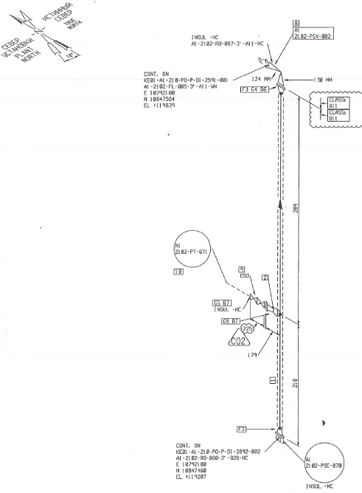
Pipe-1
Pipe-4
Pipe-3
Pipe-2
A1-2102-RO-087-3”-A11-HC/ KE01-A1-210-PO-P-DI-2906-001

Inspection results
S/NO | P&ID | Isometric No | Line No | Item description | DIA(Ø), inch | Nominal thickness, mm* | East  mm | West  mm | South  mm | North  mm | Top  mm | Bottom  mm | Extrados  mm
1 | KE-A1-210-PO-R-HP-0203-001 | KE01-A1-210-PO-P-DI-2906-001 | A1-2102-RO-087-3”-A11-HC | Pipe-1 | 2 | 5.54 | 5.74 | 5.99 | 5.38 | 6.29 | - | - | -
2 | KE-A1-210-PO-R-HP-0203-001 | KE01-A1-210-PO-P-DI-2906-001 | A1-2102-RO-087-3”-A11-HC | Pipe-2 | 2 | 5.54 | 5.69 | 5.90 | 5.35 | - | - | - | -
3 | KE-A1-210-PO-R-HP-0203-001 | KE01-A1-210-PO-P-DI-2906-001 | A1-2102-RO-087-3”-A11-HC | Pipe-3 | 2 | 5.54 | 5.68 | 5.98 | 5.42 | 6.28 | - | - | -
4 | KE-A1-210-PO-R-HP-0203-001 | KE01-A1-210-PO-P-DI-2906-001 | A1-2102-RO-087-3”-A11-HC | Pipe-4 | 2 | 5.54 | 5.60 | 5.84 | 5.43 | 6.25 | - | - | -

Examined by  UT L II cert. No 1400  expiry date: 31.01.2023 | Name: Tolegenov Alimzhan | Signature: ............................... | Date: 02 Sept 2020
Approved by:  UT Level II cert. No 2B 421/20  expiry date: 31.07.2025 | Name: Andrei Shakunou | Signature: ........................... | Date: 02 Sept 2020
Client Representative: | Name: …………………………… | Signature: .............................. | Date: ………………………

